**Townsview School Guidance Program:**

**January Newsletter**



**Theme of the Month:**

The school-wide focus for the month of January is **Empathy and Kindness (K-5)** and **Thoughts, Emotions, and Decisions (6- 8).** Empathy and Kindness involve identifying emotions in others and learning how empathy can lead us to show kindness. Recognizing thoughts, emotions, and decisions allows students to identify their own emotions and understand that emotions can affect their thoughts and decisions.

The behaviour focus for January is empathy. **Empathy** isbeing able to know how someone else is feeling, even when you aren't in the same situation. Sometimes, in more simple words, we call empathy being able to "put yourself in someone's shoes" and see things from their view.

**Guidance Program:**

Throughout January, guidance will continue supporting and enhancing student learning through academic, social-emotional, and career development. The ESS (Guidance) teacher supports whole school initiatives (such as the Second Step and Link Program), by providing resources, activities, co- planning, co-teaching, and offering small group/individual learning opportunities related to general guidance curriculum outcomes (such as emotional regulation). If you have any questions about the guidance program at TVS, please feel free to contact me at the school: 506-325-4435 or [Jessica.Irvine@nbed.nb.ca](mailto:Jessica.Irvine@nbed.nb.ca).

[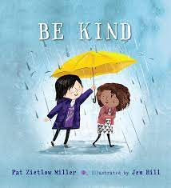](https://www.youtube.com/watch?v=t6NUJ2JZz50)[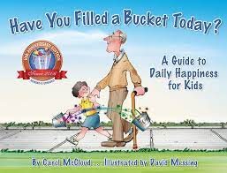](https://www.youtube.com/watch?v=z3Uohqg8Vjk)[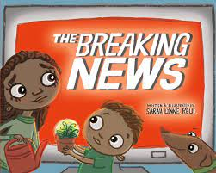](https://www.youtube.com/watch?v=b-ZZxAJcs44)[](https://www.youtube.com/watch?v=-5ou2QWVpEk)

**Family Connection: Try This at Home**

**K-2**

**Give your child a few scenarios and ask them how they would feel in the person’s shoes. For example, if they saw another student sitting alone on the playground, how would they feel? What is something kind they could do to make the other child feel better?**

**3-5**

**Tell your child about a time that made you upset. Can they tell you about a time that made them frustrated or sad? What is something kind they could do for someone in the same situation?**

**6-8**

**Discuss current events with your children and ask them how they think the people in the story might be feeling. How can someone’s feelings effect the decisions that they make. For example, if a person is irritated because they don’t understand their homework, they might more easily snap at a parent or sibling. Brainstorm together how they can change their mindset to make positive decisions when they get frustrated.**

The read alouds below support the theme of the month. You can access each read aloud the following ways:

1. YouTube (click each photo to open the link).

2. Borrow a copy from the Guidance Office.

3. Purchase a copy from [www.Amazon.ca](http://www.Amazon.ca)